**Pizzeria Case Study Part III**

**Part I: Updated EA Principle**

1. **Name:** Ensure Business Continuity by investing in Human Capital Management tools.

**Statement:** Basic Enterprise operations are maintained despite disruptions to the technology stack . Finance, planning and HR are coordinated via the WorkDay HCM application.

**Rationale:**

The enterprise should integrate finance, planning and HR through one application implementation which will foster greater productivity, talent development and operational excellence. Overall a human capital planning solution will help the enterprise maintain business continuity in the face of expansion campaigns.

**Implications:**

* The Pizzeria needs to integrate finance, human resources and planning and set KPIs for pursuing operational excellence.

Explanation:

The Pizzeria needs to utilize a human capital management tool to enable branch wide employee communication, training and scheduling. The Pizzeria needs to focus on measuring employee performance and assessing how individual contributions enable organizational objectives. Key performance indicators(KPI)s need to be established for order fulfillment, staff utilization and incentive based performance plans.

Investing in human capital is a good strategy for the pizzeria as it plans to grow to new locations. Maximizing employee productivity and improving customer experience is key to promoting brand image and developing brand loyalty. Not only is communication to the customers important but also communication between Pizzeria staff members. Training turnaround times need to be quick for delivery and baking jobs.

**Part II: Updated Business Capabilities**

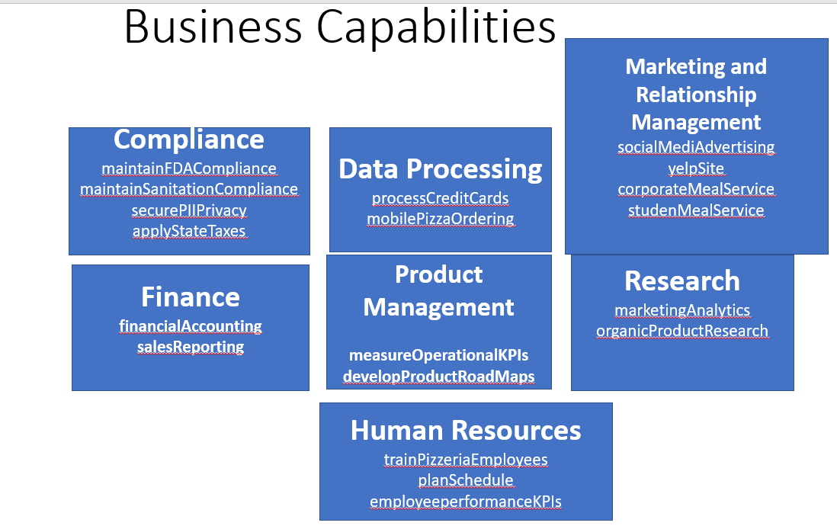

(Only amended capabilities are listed below. For the entire list refer to Assignment 4)

Research

1. marketingAnalytics- The Pizzeria needs to invest in a marketing analytics tool to optimize its return on marketing spend across products, geos and segments.
2. organicProductResearch- The Pizzeria needs its food science team to research new combinations of organic product arrangements that foster partnerships with local farming communities.

Human Resources

1. trainPizzeriaEmployees- The Pizzeria needs to have a capability of quickly training new staff across its branches.
2. planSchedule- The Pizzeria needs to enable employees to proactively manage their daily availability.
3. employeePerformanceKPIs- The Pizzeria needs to define and measure employee utilization, turnaround time and compliance to company policies.

Data Processing

1. processCreditCards- The Pizzeria needs to have a standardized payment system and a capability of processing a variety of credit cards. Currently they accept Apple Pay and Android Pay. This will make transactions digital and improve transparency and traceability across branches.
2. mobilePizzaOrdering- The Pizzeria needs to enable pizza ordering via mobile apps.

Marketing and Relationship Management

1. socialMediaAdvertising- The Pizzeria needs to advertise on social media platforms since most people share their custom made food on social media tools like facebook and Instagram.

**PART III: Future Applications and Capabilities as Projects:**

Application -Capability Map(revised)

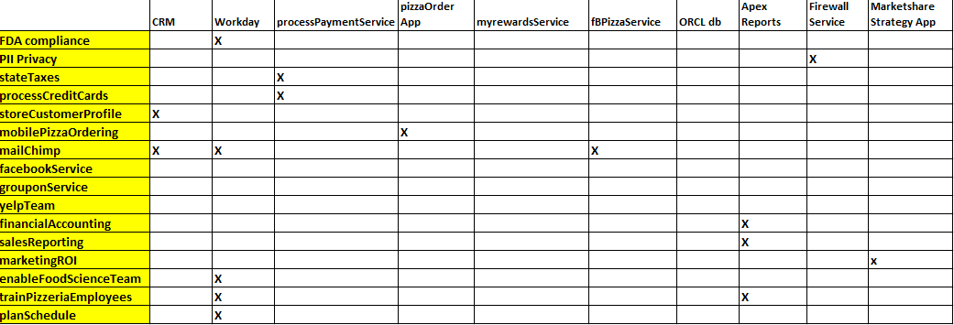

1. List of Applications
2. storeCustomerProfile- The Salesforce CRM will store customer details and history in realtime.
3. trainPizzeriaEmployees Application- The training application will train employees on sanitation and healthy practices related to baking and delivering pizza.
4. planSchedule Workday Application- The plan schedule app will use workday to provide integrated human capital management, planning and operational analytics capabilities.
5. mobilePizzaOrdering Application- The PizzaOrder mobile app will integrate with CRM and processPaymentService to enable online ordering via mobile devices in realtime.
6. processPaymentService- The SOA Application will process credit card and digital pay transactions in realtime.
7. myrewardsService- The SOA Application will process transactions in realtime and add reward points to customer profiles in CRM. Monthly points will be aggregated in batch at the end of month. Customers meeting monthly reward point benchmarks will receive menu items promotions.
8. facebookPizzaService- The SOA Application will promote sales on social media events by integrating with myrewardsService for large group orders.
9. firewallService- the firewall will guard the site from intrustions and protect the cloud database from attacks keeping safe PII.
10. oracleCloudDatabase- the SOA Applications will write to the oracle database via CRUD statements.
11. oracleApEXReports- the database data will be uploaded to ApEx via batch process every quarter and reports will be implemented in dashboards for KPIs.

Project Stages:

(Please zoom on this image using zoom slider in word for project stages info)

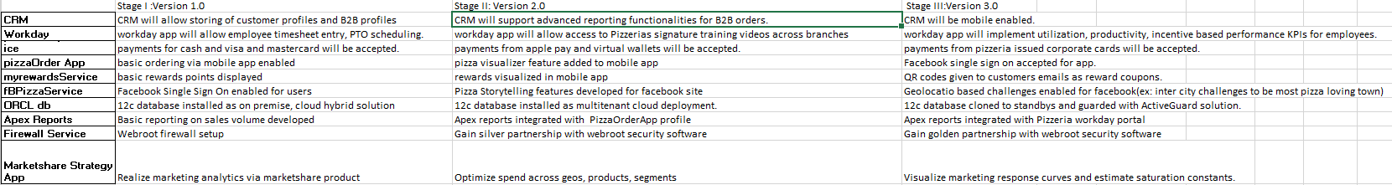

**PART IV: Data Architecture for Future State EA**

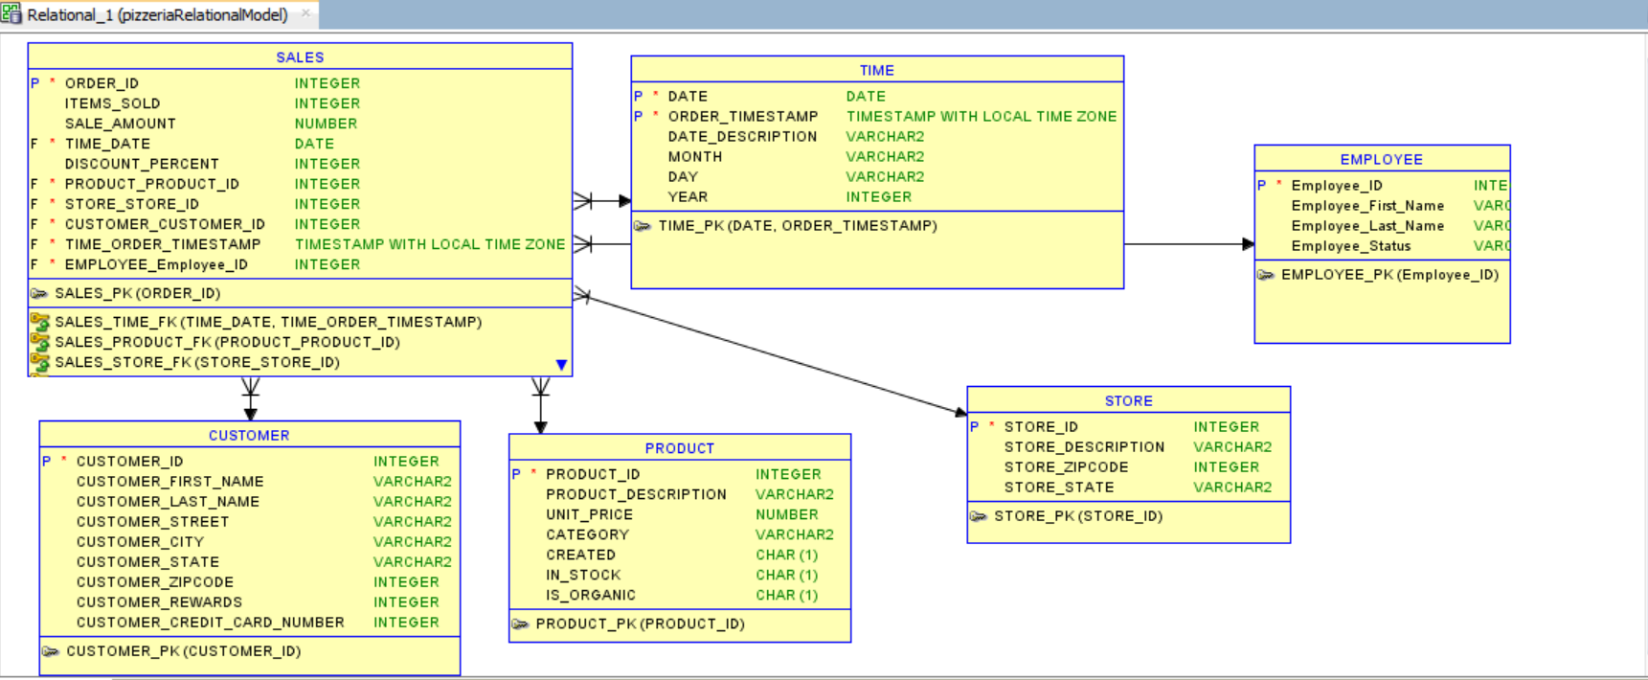

I have chosen to enable human capital management via workday application. To do this I need to account for all employees using an employee id primary key in my ERD.

I added the EMPLOYEE table to track employees in workday and associate them with sales fulfillment functions such as baking and delivery. The timestamps in SALES table associated with each order and employees assigned to it will further help establish KPIs for employee productivity and set new benchmarks in baking and delivery times.

I will use CUSTOMER and STORE entities to facilitate the generation of operational KPI data that supports expansion to newer locations.

I will use the CUSTOMER and SALES entities to facilitate the generation of transactional KPI data that supports targeted marketing and rewards program enrollment for most loyal patrons.

CRUD Diagram:

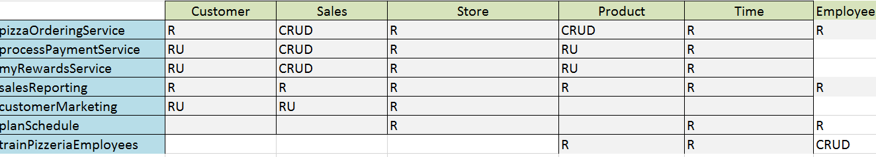

**PART V: Application Technical Architecture: AS-IS /TO-BE**

1. **Application Description**
2. **AS-IS**

Business Name: Salesforce CRM

Business Owner: Marketing and Customer Relationship

Business Issue: This app will require trained salesforce admins and developers to maintain.

Platform: Salesforce Platform which is cloud enabled.

Processing: Salesforce CRM supports Realtime incident logging and batch reporting functions.

Maturity: Customizable COTS, currently supported by Salesforce.org.

**TO-BE**: This application will be deployed on the cloud and integrate with oracle 12c database clones that will be used for sales volume and employee productivity report generation. The application will be developed in stages. In stage 1 the application will support storing of customer and B2B profiles. In stage2 the application will enable advanced reporting features on B2B customers. In stage3 the application will be mobile enabled.

1. **AS-IS**

Business Name: Workday

Business Owner: Human Resources Department

Business Issue: This app will connect employees to internal knowledge base , scheduling and training portal. By ensuring training and planning workday app will enact compliance, maintain standards and foster innovation.

Platform: Workday Platform which is cloud enabled.

Processing: Knowledge repository and talent management system.

Maturity: Customizable COTS, currently supported by Workday.org

**TO-BE:** This application will be cloud enabled. The stage1 workday application will allow timesheet entry, PTO scheduling. The stage2 workday app will allow access to organization wide training videos. The stage3 workday app will track employee performance KPIs and performance reports.

1. **AS-IS:**

Business Name: processPaymentService

Business Owner: Data Processing Department

Business Issue: Implemented as a webservice this will enable card transactions from a variety of vendors and integrate to Apple Pay and Android Pay API’s

Processing: Realtime

Platform: IBM Websphere Application Servers

Maturity: prototype

**TO-BE:** The process payment service will enable payment acceptance from a variety of sources. The stage1 service will enable payments from cash and visa, mastercard vendors. The stage2 service will enable payments from apple pay and virtual wallets. The stage3 service will enable payments by pizzeria issued corporate card for B2B customers.

1. **AS-IS:**

Business Name: myRewardsService

Business Owner: Data Processing Department/Customer Relations Department

Business Issue: Implemented as a webservice this will enable reward point tracking for customers in the rewards program.

Processing: batch processing at end of reward period.

Platform: IBM Websphere Application Servers

Maturity: prototype

**TO-BE:** The rewards service will help the customers redeem benefits for loyalty to the Pizzeria. Stage1 will enable basic rewards points tracking. Stage 2 will enable rewards visualizations (twitter and facebook emoji stickers). Stage 3 will enable QR code reward coupons sent via email or text message to customers.

1. **AS-IS:**

Business Name: firewallService

Business Owner: Data Processing

Business Issue: Implemented on web site and around orcl 12c cloud database this service will ward off intrusions.

Processing: realtime

Platform: Symantec Firewall

Maturity: COTS

**TO-BE**: The firewall service will attain bronze, silver and gold level partnerships with webroot in stages 1, 2 and 3.

1. **AS-IS:**

Business Name: ApEx Reports Service

Business Owner: Finance and Product Management

Business Issue: Implemented as master and detail pages sourced from orcl tables the reports in apex will account for quarterly sales reporting and customer analysis.

Processing:batch processing on a quarterly basis

Platform: Oracle ApEx

Maturity: COTS with customization by database developers

**TO-BE:** The Apex reports will improve in integration over the next few stages. It will first enable sales volume reporting in stage 1. Next it will source data from SALES table and visualize order fulfillment KPI’s in stage2. In stage3 it will source data from EMPLOYEE table to visualize operational efficiency KPI’s reports.

1. **AS-IS:**

Business Name: Marketshare Strategy App

Business Owner: Marketing and Finance

Business Issue: This analytics platform will enable Pizzeria to visualize return on marketing spends.

Processing:batch processing on a quarterly basis as it needs historical spend data across channels, segments and geos.

Platform: Marketshare Modeling Analytics Platform

Maturity: COTS, customizable to national branches of Pizzeria.

**TO-BE:** The Marketshare Strategy application will realize marketing analytics in stage1. In stage2 it will optimize spends across geos, products and segments, In stage 3 we will analyze response curves in detail and feed more actualized data to the marketing mix model to develop better regression and prediction curves.

1. **AS-IS:**

Business Name: ORCL 12c cloud database

Business Owner: Data Processing

Business Issue: ORCL 12c relational database will be the backend service that will persist transaction details and customer metadata.

Platform: ORCL 12c

Processing: realtime

Maturity: COTS, maintained by dba and db developer.

**TO-BE:** The database will grow from on-premise /hybrid cloud setup to full cloud setup. It will become multitenant and utilize backup and cloning services.

These changes reflect my EA principles of enabling business continuity via the use of human capital management applications. I will integrate financial reporting, operational KPI’s and human resource planning to make my business more resilient to market disruptions in capital, resources and competitors.

Enabling better CRM will make my business more connected in the marketplace. It will help drive b2b sales and develop long term meaningful relationships with other businesses in the area. Efficient Workday application use will enable the Pizzeria staff to plan working schedules and holidays. KPI’s from workday related to incentive based employee productivity performance will back up hiring practice revisions. Enabling diverse payment services will tap into more customers wallets and generate additional revenue stream for the Pizzeria. Implementing rewards service program will foster loyalty and promote brand reputation amongst Pizzeria’s customers. Apex reporting will visualize employee performance KPI’s and operational KPI’s to help optimize key baking and delivering business processes. Oracle cloud deployment and multitenancy will secure customer data and open the Pizzeria to data engineering analysis in the future. Firewall services will guard transactions and customer data and keep PII safe from third parties generating trust between the Pizzeria and its customers.

All the above features will guarantee business continuity through integration of secure and performant services.

**PART VI: Technical Architecture Diagram**

**AS -IS Diagram**

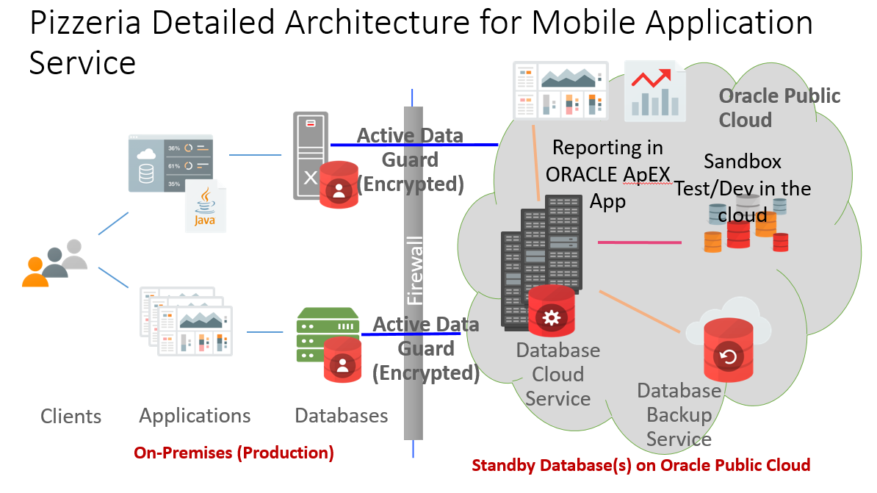

My AS-IS architecture is a hybrid cloud approach that can be enabled by on premise oracle 12c database install that is backed up the the cloud and integrated with APEX reporting server. The pizzaOrdering Mobile app will integrate with database which will be encrypted via active data guard to allow fast updates to backup database.

**TO-BE Diagram**

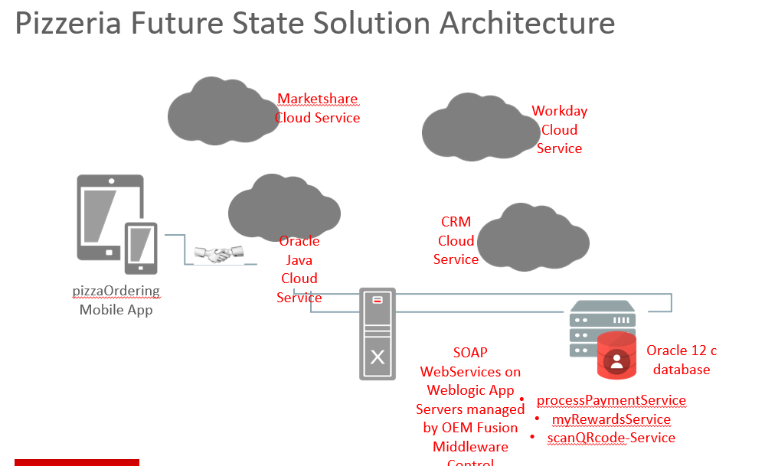

My TO-BE architecture will be integrated at cloud level amongst various cloud applications: workday, java cloud, crm, marketshare strategy cloud. The webservices will be hosted in oracle java cloud which comes with a oracle database cloud instance. The webservices and databases can be monitored by Oracle Enterprise Fusion Manager Middleware control dashboard.